## **User Guide for NESREA WEBSITE** https://nesrea.gov.ng

This guide will help you understand how to manage the NESREA website using the WordPress admin dashboard. Specifically, it covers:

1. How to Navigate the WordPress Admin Dashboard
2. How to Add a Blog Post
3. How to Add a New Page

## **1. How to Navigate the WordPress Admin Dashboard**

### **Step 1: Login**

* Go to: https://nesrea.gov.ng/wp-admin
* Enter your **username** and **password**
* Click **Log In  
  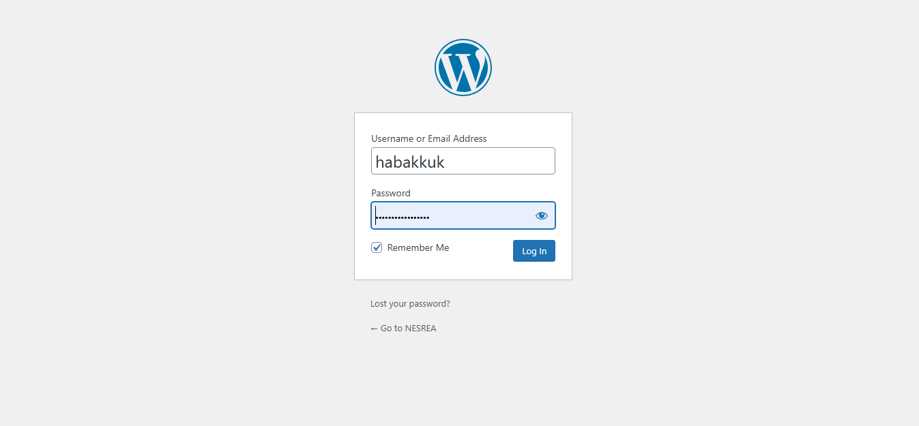**

### **Step 2: Admin Dashboard Overview**

After logging in, you’ll see the **WordPress Dashboard**, which includes:

* **Dashboard**: Overview of website activity
* **Posts**: Manage blog posts
* **Pages**: Manage static pages (like About Us, Services, etc.)
* **Media**: Manage uploaded images and files
* **Appearance**: Customize theme and menu
* **Plugins**: Manage installed plugins
* **Users**: Manage website users
* **Settings**: Site-wide settings
* **Comments**: Moderate blog comments

💡 **Tip**: Hover over any menu item to view its sub-options.  
  
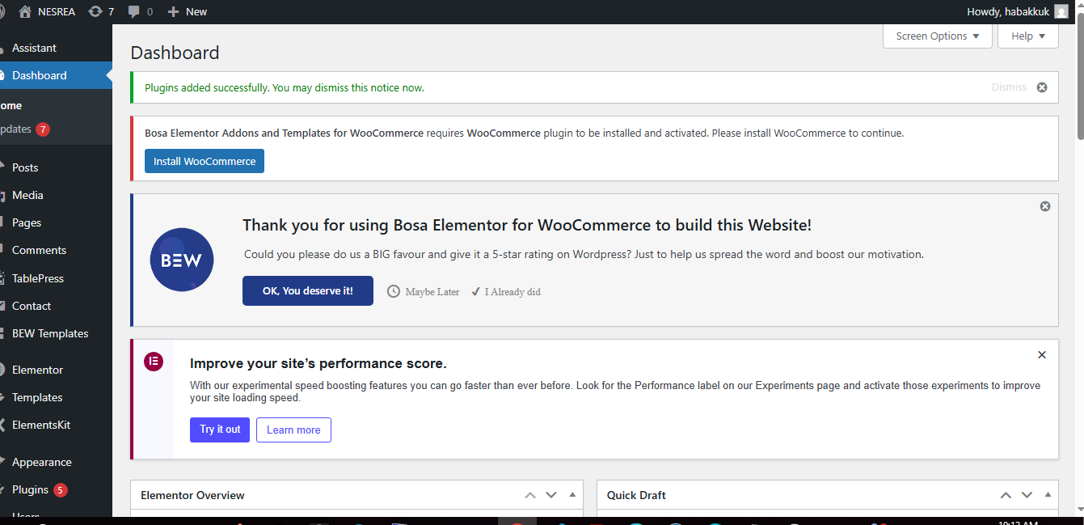

## **2. How to Add a Blog Post**

To add a new blog article or news item to NESREA’s website:

### **Step 1: Go to Posts**

* From the left-hand menu, click **Posts**
* Then click **Add New  
    
  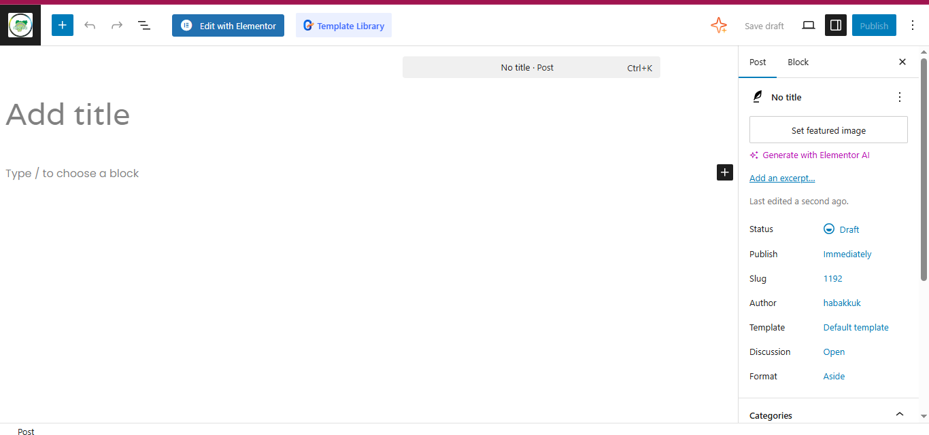**

### **Step 2: Add Your Content**

* **Title**: Enter the post title (e.g., “NESREA Launches New Environmental Campaign”)
* **Content**: Add your article in the content area using the block editor  
  + You can add text, images, headings, links, etc.
  + Use the **+** button to add new blocks (paragraphs, images, etc.)  
      
    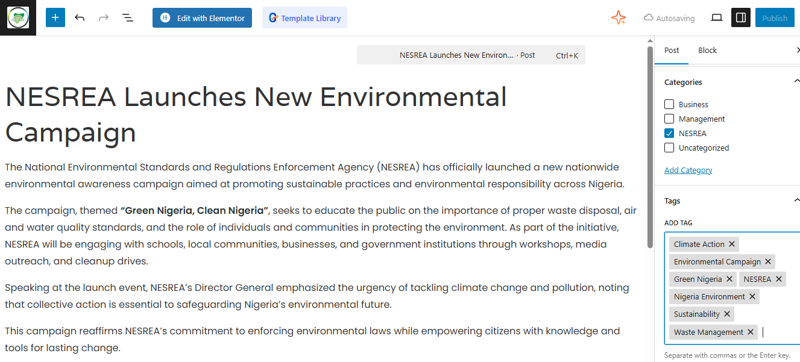

### **Step 3: Add Categories and Tags**

* On the right-hand sidebar:  
  + Under **Categories**, check the relevant category or create a new one
  + Under **Tags**, enter relevant keywords separated by commas  
    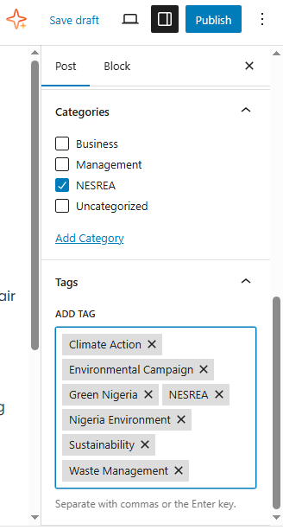

### **Step 4: Set a Featured Image**

* In the right-hand sidebar, click **Featured Image**
* Click **Set featured image**, choose or upload an image, and click **Set  
  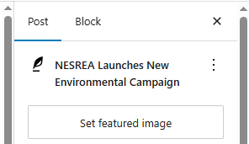**

### **Step 5: Publish the Post**

* Click the **Publish** button (top right)
* Confirm by clicking **Publish** again  
    
  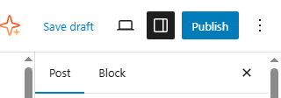

Your blog post will now appear on the News or Blog section of the site.

## **3. How to Add a New Page**

To add a static page like “Mission & Vision” or “Annual Reports”:

### **Step 1: Go to Pages**

* Click **Pages** in the left-hand menu
* Then click **Add Page  
  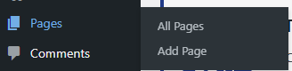**

### **Step 2: Add Page Content**

* **Title**: Type the title of the page
* **Content**: Use the block editor to add your content  
  + You can include text, images, links, tables, etc.  
      
      
    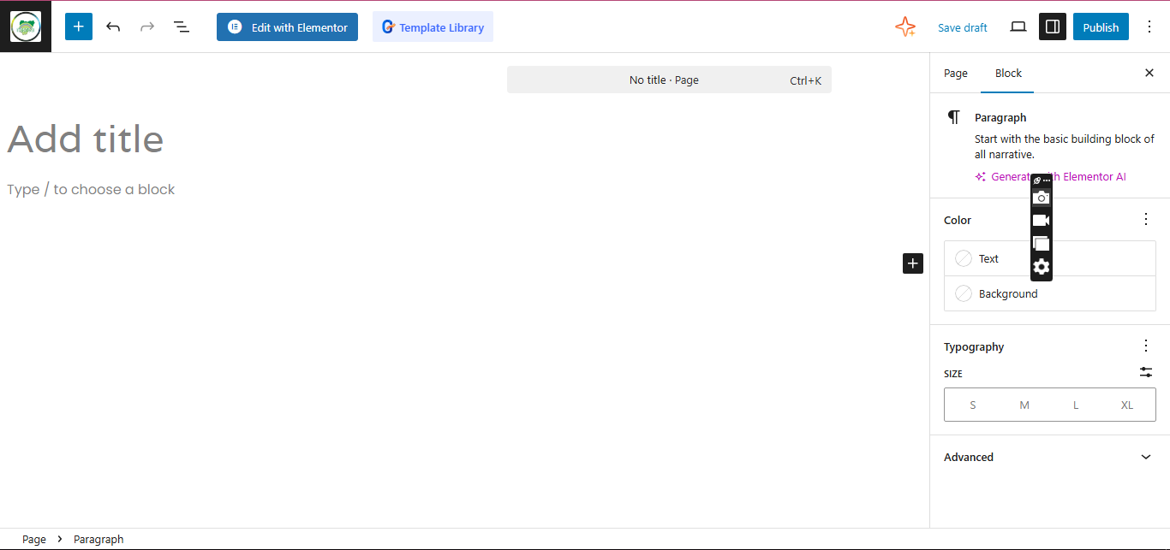

### **Step 3: Choose Page Template (Optional)**

* In the **Page Attributes** section on the right, you can choose a template (depends on the theme used)

### **Step 4: Publish the Page**

* Click the **Publish** button
* Confirm again to publish  
  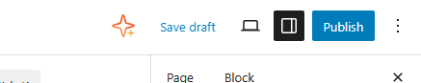

### **Step 5: Add to Menu (Optional)**

To make this page appear in the main menu:

1. Go to **Appearance > Menus**
2. Select the main menu (usually labeled “Main” or “Primary”)
3. On the left, check your new page and click **Add to Menu**
4. Drag it to the desired position and click **Save Menu**

## **Extra Tips**

* **Editing Existing Posts or Pages**: Go to **Posts** or **Pages**, hover over the item, and click **Edit**.
* **Preview Before Publishing**: Use the **Preview** button to see what the content looks like before publishing.
* **Media Library**: All uploaded images and files can be found under **Media > Library**.
* **User Roles**: Make sure you have appropriate permissions. Editors and Admins can add/edit content.

## **Need Support?**

If you encounter issues or need technical help:

* Contact the site administrator or web developer
* Or check the WordPress support docs at https://wordpress.org/support/

**End of Guide** **NESREA Web Team – Updated 2025**